


The Fourth Jason Price
Memorial Longbow
Tournament in
Aid of Herriot Hospice
Double two-way Stafford
To BLBS Rules
At Baldersby Park YO7 3PG
What 3 words …
crispier.bordering.bared
Saturday August 15th
2026

2025

IN MEMORY OF DR. JASON PRICE
1971 - 2022
R0UND – DOUBLE TWO WAY STAFFORD  12 DOZEN ARROWS @ 32.4YDS  ASSEMBLE AT 10.00 AM  FIRST ARROW – WHEN READY  PRIZE LIST  LADIES –  MOST HITS – TROPHY AND MEDAL  HIGHEST SCORE – MEDAL  MOST GOLDS – MEDAL  GENTS –  MOST HITS – TROPHY AND MEDAL  HIGHEST SCORE – MEDAL  MOST GOLDS – MEDAL  1ST JUNIOR BOY – TROPHY AND MEDAL  1ST JUNIOR GIRL – TROPHY AND MEDAL  SHERRY AND FRUIT CAKE THROUGHOUT THE DAY  TEA AND BUTTIES ETC. AVAILABLE THROUGHOUT THE DAY |  | ENTRY FEE  (NON-REFUNDABLE)  SENIORS - £15.00 JUNIORS – £10.00  ENTRIES WILL BE TAKEN ON THE DAY (RING FIRST IF POSSIBLE)  PLEASE SEND YOUR ENTRIES TO –  IAN HUNTER  SOUTHDENE, THORNTON-LE BEANS, NORTHALLERTON,  N.YORKS. DL6 6SW  BACS PAYMENT PREFERRED  Acc No. 35797592 Sort code 05-09-44  (Please put your name and tournament as ID e g. Hunter – Jason) Tel : 07541829640  E MAIL : ianchunter66@hotmail.com  CHEQUES SHOULD BE MADE PAYABLE TO – THIRSK BOWMEN  In accordance with G.N.A.S Child Protection and Vulnerable Adults Policy guidelines, all persons any wishing to use any type of still photo, video, or mobile phone picture recording equipment must register their interest with the event organiser on the day of the event.  When you enter a competition the following information may be collected and shared with tournament organisers, scoring systems and other  competitors, for example : Target Lists and Results may be published, ie: First name, Surname, Gender, Bow Style, D.O.B., e-mail, phone number and club.

Jason Price Stafford 2026
NAME ………………………………. AGE IF JNR ………….. ADDRESS …………………………………………………………..
POST CODE ………………….. TEL No ………………………
CLUB ………………………. BLBS/AGB No ………………..
E MAIL ………………………….@.................................

BANK TRANSFER ID

Jason Price Stafford 2026
NAME ………………………………. AGE IF JNR ………….. ADDRESS …………………………………………………………..
POST CODE ………………….. TEL No ………………………
CLUB ………………………. BLBS/AGB No ………………..
E MAIL ………………………….@.................................

BANK TRANSFER ID

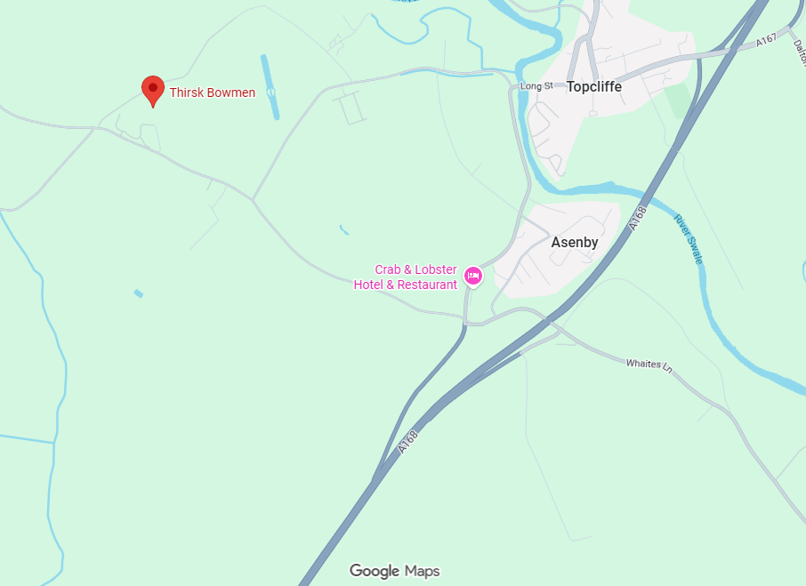

From junction 49: A1(M), take the A168 to Thirsk and Teesside. Exit at the first junction to Asenby. Take the first left to Rainton (before the Crab and Lobster) and Baldersby Park is half a mile on the right, immediately after Nursery Gardens Caravan Park.

